 | Filing Reference : |  | GG/COMS/TS.2/5
 | Document Title : |  | Use-Case Realization Report (Analysis)  Manage Employee Role
 | Version : |  | 1.0
 | Prepared By : |  | Alvin Chang
 | Date Created : |  | Monday, Jul 30th, 2011
Approved By :
 |  | Tran Ba Tien |  | Date
 |  | Project Manager |  | 30th Jul 2011

©2011 [Hoang Kim joint stock Company].
The information contained in this document is the property of [Hoang Kim joint stock Company]. The contents must not be reproduced, wholly or in part, for purposes other than for which it has been supplied, without the prior permission of [Hoang Kim joint stock Company], or, if it has been furnished under contract to another party, as expressly authorised under that contract. [Hoang Kim joint stock Company] shall not be liable for any errors or omissions.

Revision History
Date | Version | Description | Author
30/JUL/2011 | 1.0 | First version | Alvin Chang

Table of Contents
1. Brief Description 4
2. Flow of Events 4
3. Interaction Diagrams 4
3.1 Add Employee-Role 5
3.2 Refresh Employee-Role Page 6
3.3 Remove Employee-Role 6
4. Participating Objects 6
5. Class Diagrams 7
5.1 Manage Employee-Role 7

Use-Case Realization Report
Manage Employee-Role

Brief Description

This use case enables a department manager to manage the roles held by any particular employee. This includes the addition, and removal of employee-role relationship records.

Flow of Events
The standard flow of events for this use case and any exceptions are described in the following subsections. See section 3 for an overview of the participating Actors and Domain Objects.

Add Employee-Role
This use case is to add role to an employee.

Preconditions
- To commence using the system, user is required to log in successfully. Refer to Log In Use Case for detail.
- Department Manager navigated to EmployeeRolePage via MainPage.
- EmployeeRolePage has been successfully initialized (Refreshed). Refer to Refresh Employee Role Page Use Case for details (2.2).

2.1.2 Standard Flow
- Department Manager addRoleToEmployee() on the EmployeeRolePage
- This addRoleToEmployee() to MainController.
- MainController in turn calls addRoleToEmployee() to the EmployeeController, which addRoleToEmployee() to Employee.
- MainController then refreshEmployeeRoles() the EmployeeRolePage.
- This marks the end of this use case.

2.1.3 Exception
1. If error in adding the employee role, an error message will be shown to the user.

2.2 Refresh Employee-Role Page
This use case is to initialize / update / refresh the EmployeeRolePage.

2.2.1 Preconditions
- To commence using the system, user is required to log in successfully. Refer to Log In Use Case for detail.

2.2.2 Standard Flow
- Department Manager calls initiateModifyEmpllooyeeRoles() in MainPage.
- It calls showEmployeeRolePage() in the MainController, which then calls show() to EmployeeRolePage
- EmployeeRolePage will then initiateEmployeeRoles() to MaionController, which will call getAllRoleTypes() from RoleController, which will getAllRoleTypes() from Role.
- MainController will then call getCurrentEmployeeRoles() to EmployeeController, which will getRoles() from Employee.
- MainController will then refreshEmployeeRoles() on EmployeeRolePage.
- This marks the end of this use case.

2.2.3 Exception
1. If error in retrieving role types, an error message will be shown to the user
2. If error in getting the current employee roles, an error message will be shown to the user

2.3 Remove Employee-Role
This use case is to remove a role from an employee.

2.3.1 Preconditions
- To commence using the system, user is required to log in successfully. Refer to Log In Use Case for detail.
- Department Manager navigated to EmployeeRolePage via MainPage.
- EmployeeRolePage has been successfully initialized (Refreshed). Refer to Refresh Employee Role Page Use Case for details (2.2).

2.3.2 Standard Flow
- Department Manager calls removeRoleFromEmployee() in EMployeeRolePage.
- This calls removeRoleFromEmployee() in MainController, which will then call removeRoleFromEmployee() in EmployeeController.
- EmployeeController will then removeRoleFromEmployee in Employee.
- MainController will then refreshEmployeeRoles() in EmployeeRolePage.
- This marks the end of this use case.

2.3.3 Exception
1. If error in removing the employee role, an error message will be shown to the user.

Interaction Diagrams

Add Employee-Role
: EmployeeRolePage
: Department
Manager
Add Employee-Role:
Follows from Refresh Employee-
RolePage Use Case
: EmployeeController
: Employee
: MainController
2: addRoleToEmployee( )
5: refreshEmployeeRoles( )
1: addRoleToEmployee( )
4: addRoleToEmployee( )
3: addRoleToEmployee( )

Refresh Employee-Role Page
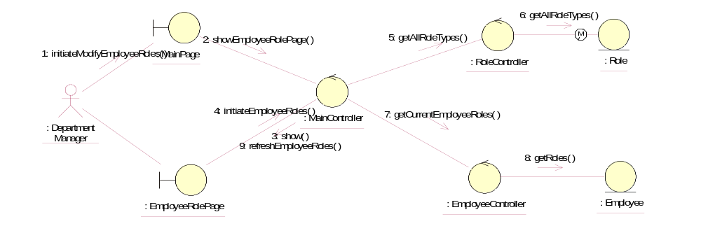

Remove Employee-Role
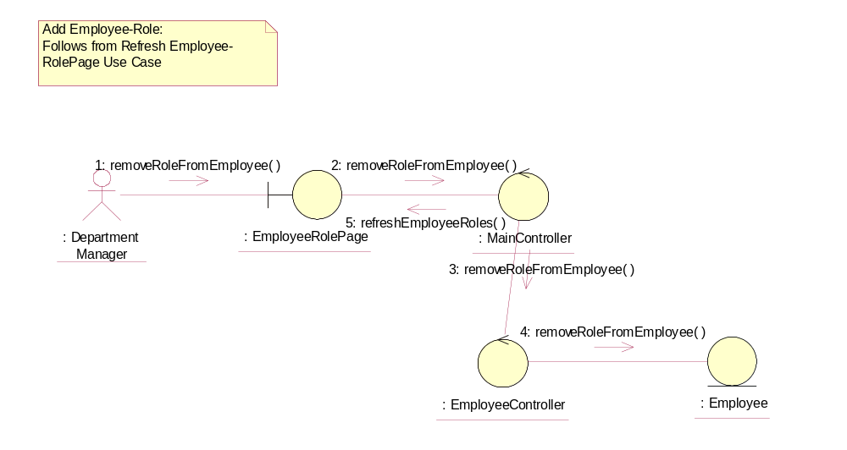

Participating Objects
: Department Manager
This actor represents the Department Manager of Golden Gravure.

: EmployeeController
This object controls the operations of the Employee object

: Employee
This object contains information about the employee

: EmployeeRolePage
This page represents the page where the Department Manager will add / remove the roles to / from the employee.

: Role
This object contains information about the roles.

: RoleController
This object controls the operations of the Role object.

: MainPage
This page represents the UI where the user of the system will first enter, and act as a launchpad for the other various pages within the system.

MainController
This object acts as the middleman between the boundary objects and other controllers

Class Diagrams

Manage Employee-Role
Employee
(from Logical View)
MainPage
(from Logical View)
EmployeeRolePage
(from Logical View)
EmployeeController
(from Logical View)
1
0..n
1
0..n
MainController
(from Logical View)
1
1
1
1
1
1
1
1
1
1
1
1
RoleController
(from Logical View)
1
1
1
1
Role
(from Logical View)
1
0..n
1
0..n

Derived Requirements
None

